Order Extracts
To review an order shown and prep it for submission to Kubota, click on the green symbol in the Submit column.
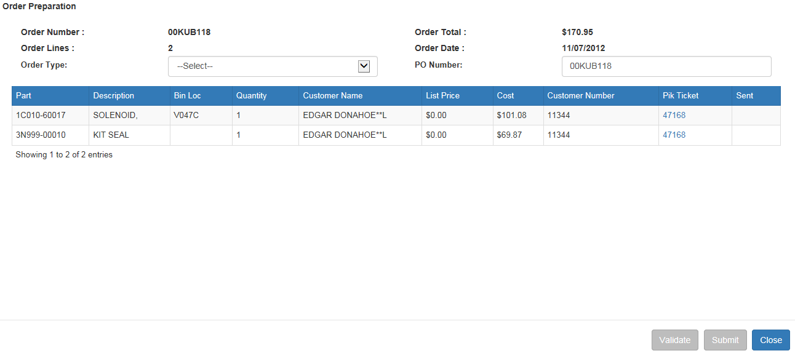
From the Order Preparation screen, you can change the PO number as needed and choose the order type.
- Valid order types are:
  - EM=Emergency
  - PR=Promotional
  - RG=Regular
  - ST=Stock
  - ZDST=Daily Stock
- When you choose Regular or Emergency order types, there is an optional checkbox for entering a special shipping address.
  - When checked, the screen opens to offer the ability to enter the shipping address for the order. You may:
    - Enter a shipping address in the fields provided and validate it against the customer file
    - Look up a customer address from the system (click on “Lookup Address” and search for the customer).
Validate: When you have the order type selected and optionally entered the shipping address, you may validate the information before the order is submitted by clicking on the “Validate” button.
- The validation step provides the following:
  - A validation message showing either (see below images):
    - Success
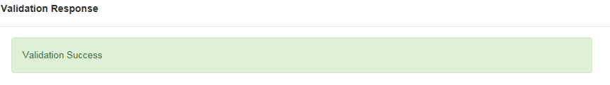

    - A reason why the order is not valid
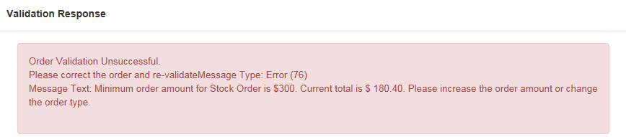
  - Dealership name
  - Dealer number
  - Total cost of order date
  - Billing info
  - Ship-to address info.
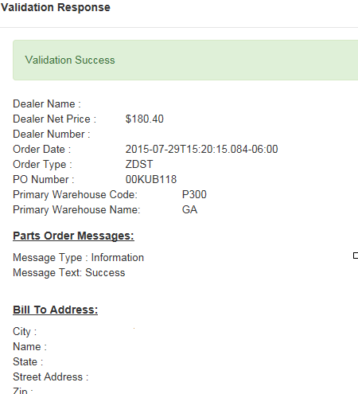
Each order line item is also reported with details like those shown below.
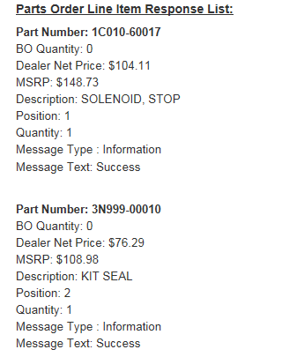

Finishing the Order: When ready, click “Submit” to send the order to Kubota.

